**Spatial memory:** The human brain develops spatial memory to find umpteen methods to remember certain things. It could be landmarks, colors, stories, etc that are related to the thing we are searching for.

Areas of the brain that are required for the formation of spatial representations of the environment include the hippocampus and surrounding medial temporal lobes, which are also known to play a key role in episodic memory (the memory system for specific events).

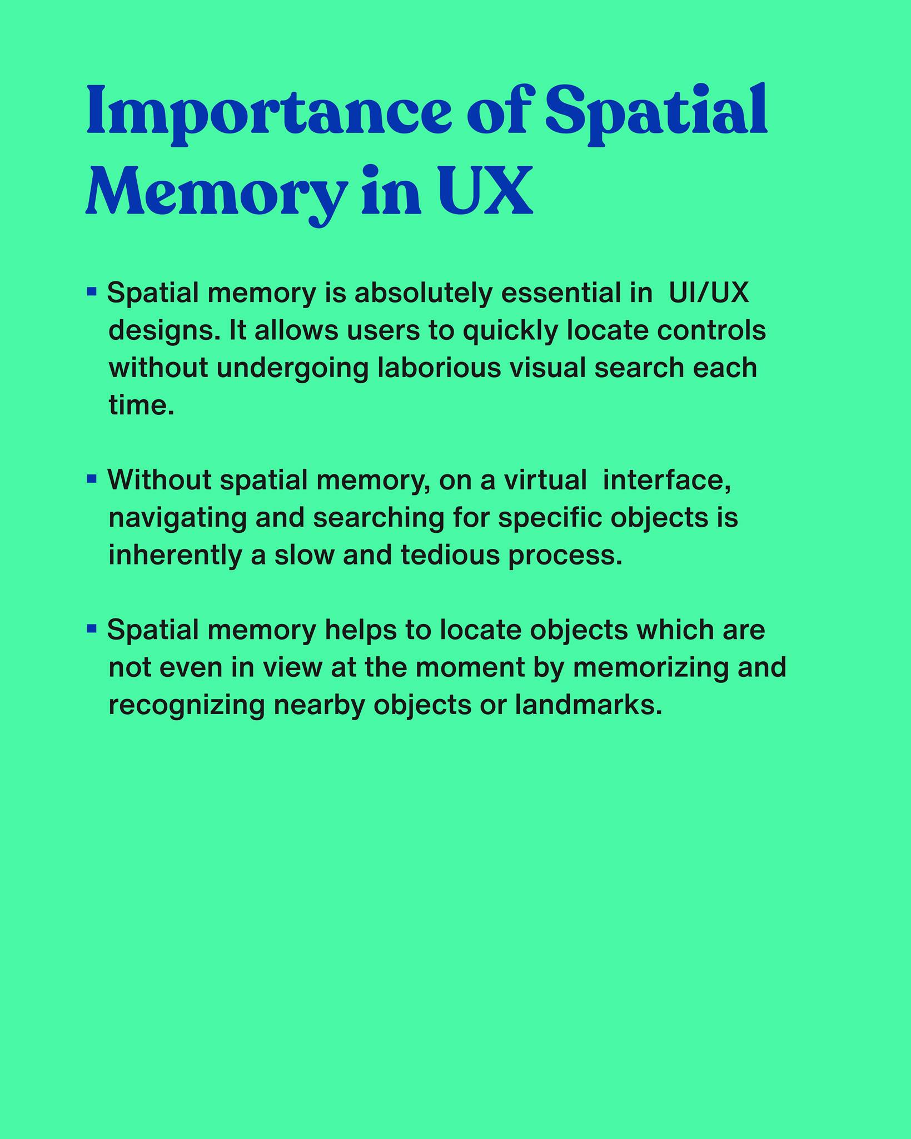

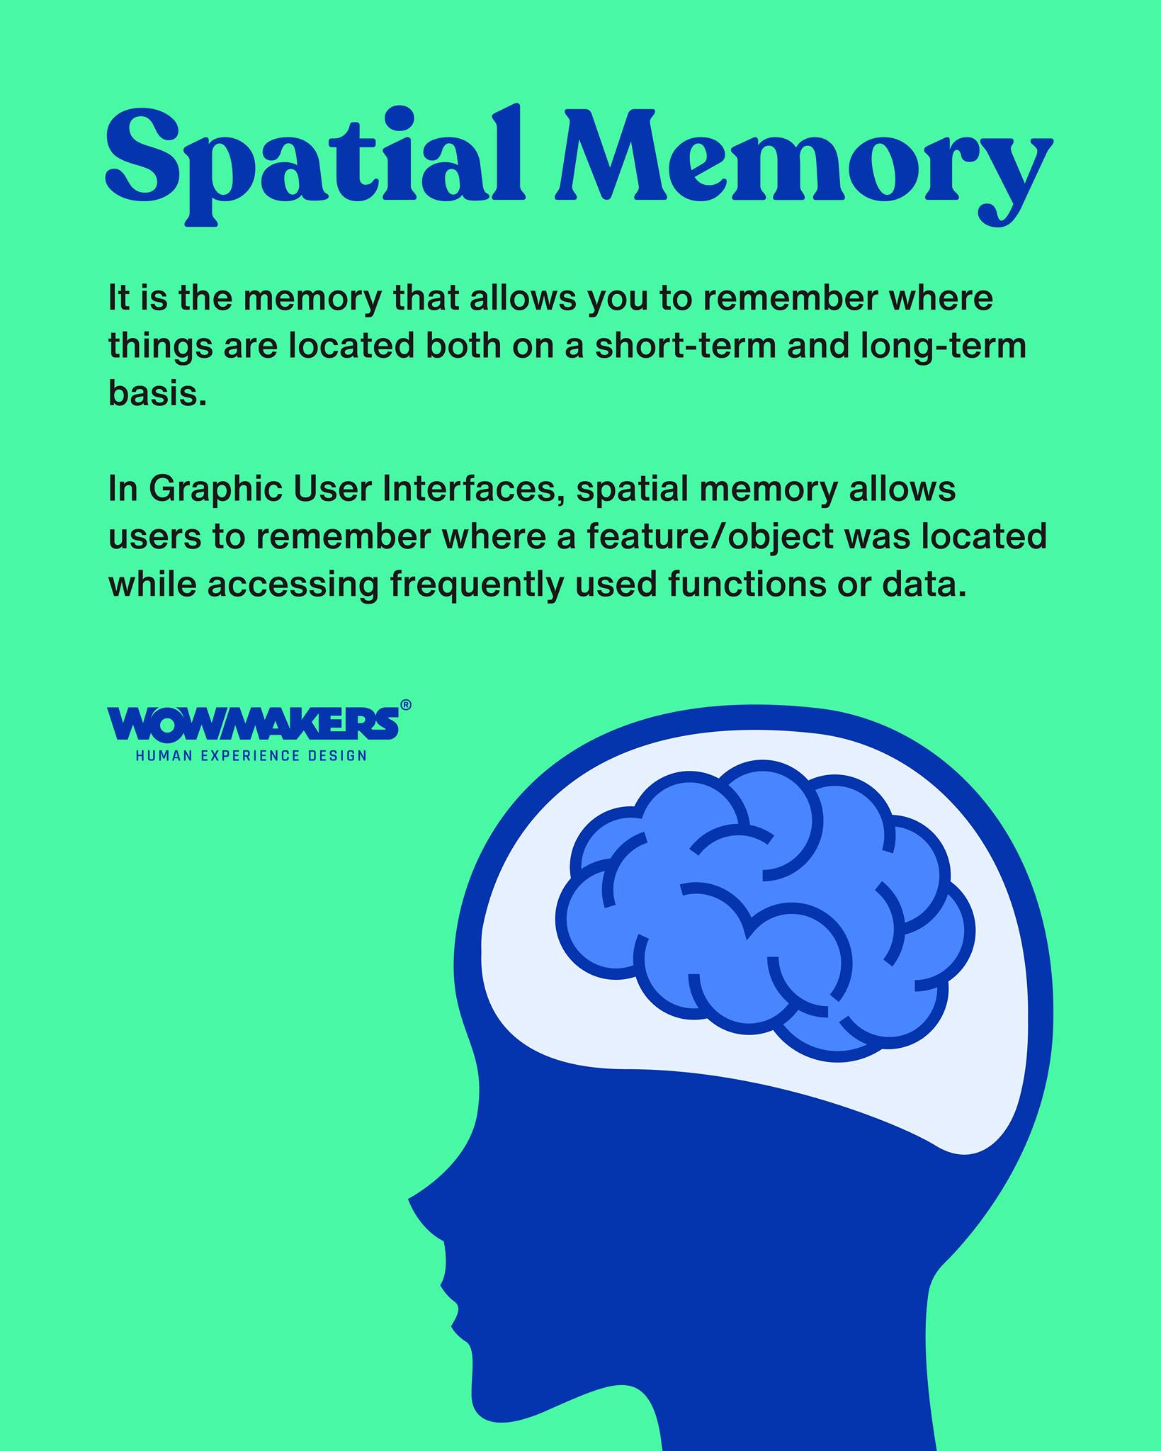

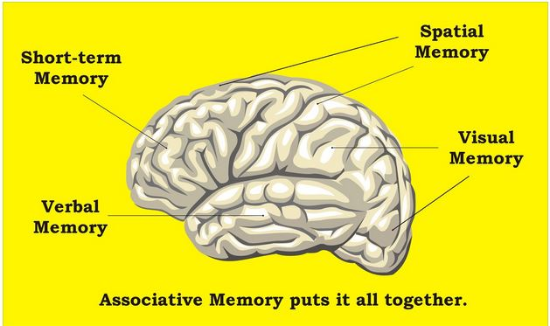

**Hippocampus,** region of the brain that is associated primarily with memory. The hippocampus, which is located in the inner (medial) region of the temporal lobe, forms part of the limbic system, which is particularly important in regulating emotional responses. The hippocampus is thought to be principally involved in storing long-term memories and in making those memories resistant to forgetting, though this is a matter of debate.

The hippocampal formation is a network of key brain regions involved in forming this coherent representation of external space. The hippocampal formation is located bilaterally in the medial temporal lobe, encompassing the hippocampus, the dentate gyrus, and the subicular cortex.

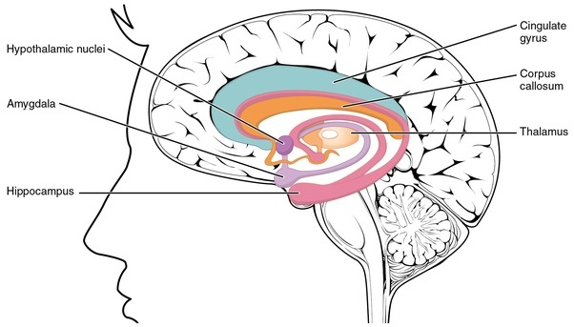

In this technique, a person is shown a series of images or objects, and their brain activity is measured as they try to recall the location of those objects in space. This technique uses a cubical space model to represent the spatial relationships between objects, and it can help researchers understand how the brain encodes and retrieves information about spatial memory.

what "spatial memory retrieval means"?

**Spatial memory retrieval refers to the process of recalling information about the location of objects or events in space.** **It is a fundamental cognitive ability that allows us to navigate our environment and find our way around**. Spatial memory is typically processed by a specific part of the brain called the hippocampus, which plays a key role in spatial navigation and memory. When we need to remember the location of an object or event, the hippocampus retrieves the relevant information from our memory and uses it to guide our behavior.

technique that uses brain imaging to study how the brain retrieves information about spatial memory. It uses a cubical space model to represent the spatial relationships between objects, and can help researchers understand how the brain encodes and retrieves spatial information. Spatial memory retrieval is the process of recalling information about the location of objects or events in space. It is important for navigation and everyday functioning.

what is spatial memory?

Spatial memory is the part of memory that is responsible for remembering information about the location of objects or events in space. It allows us to remember the layout of a room, the location of objects within it, and the route we took to get there.

what is cubical space?

Cubical space is a mathematical model used to represent the spatial relationships between objects. It is a type of geometric space that is composed of a grid of small cubes, each representing a specific location or region in space. In the context of "brain decoding in spatial memory retrieval using cubical space," **the cubical space model is used to represent the locations of objects or events in space, and to study how the brain encodes and retrieves information about those locations**.